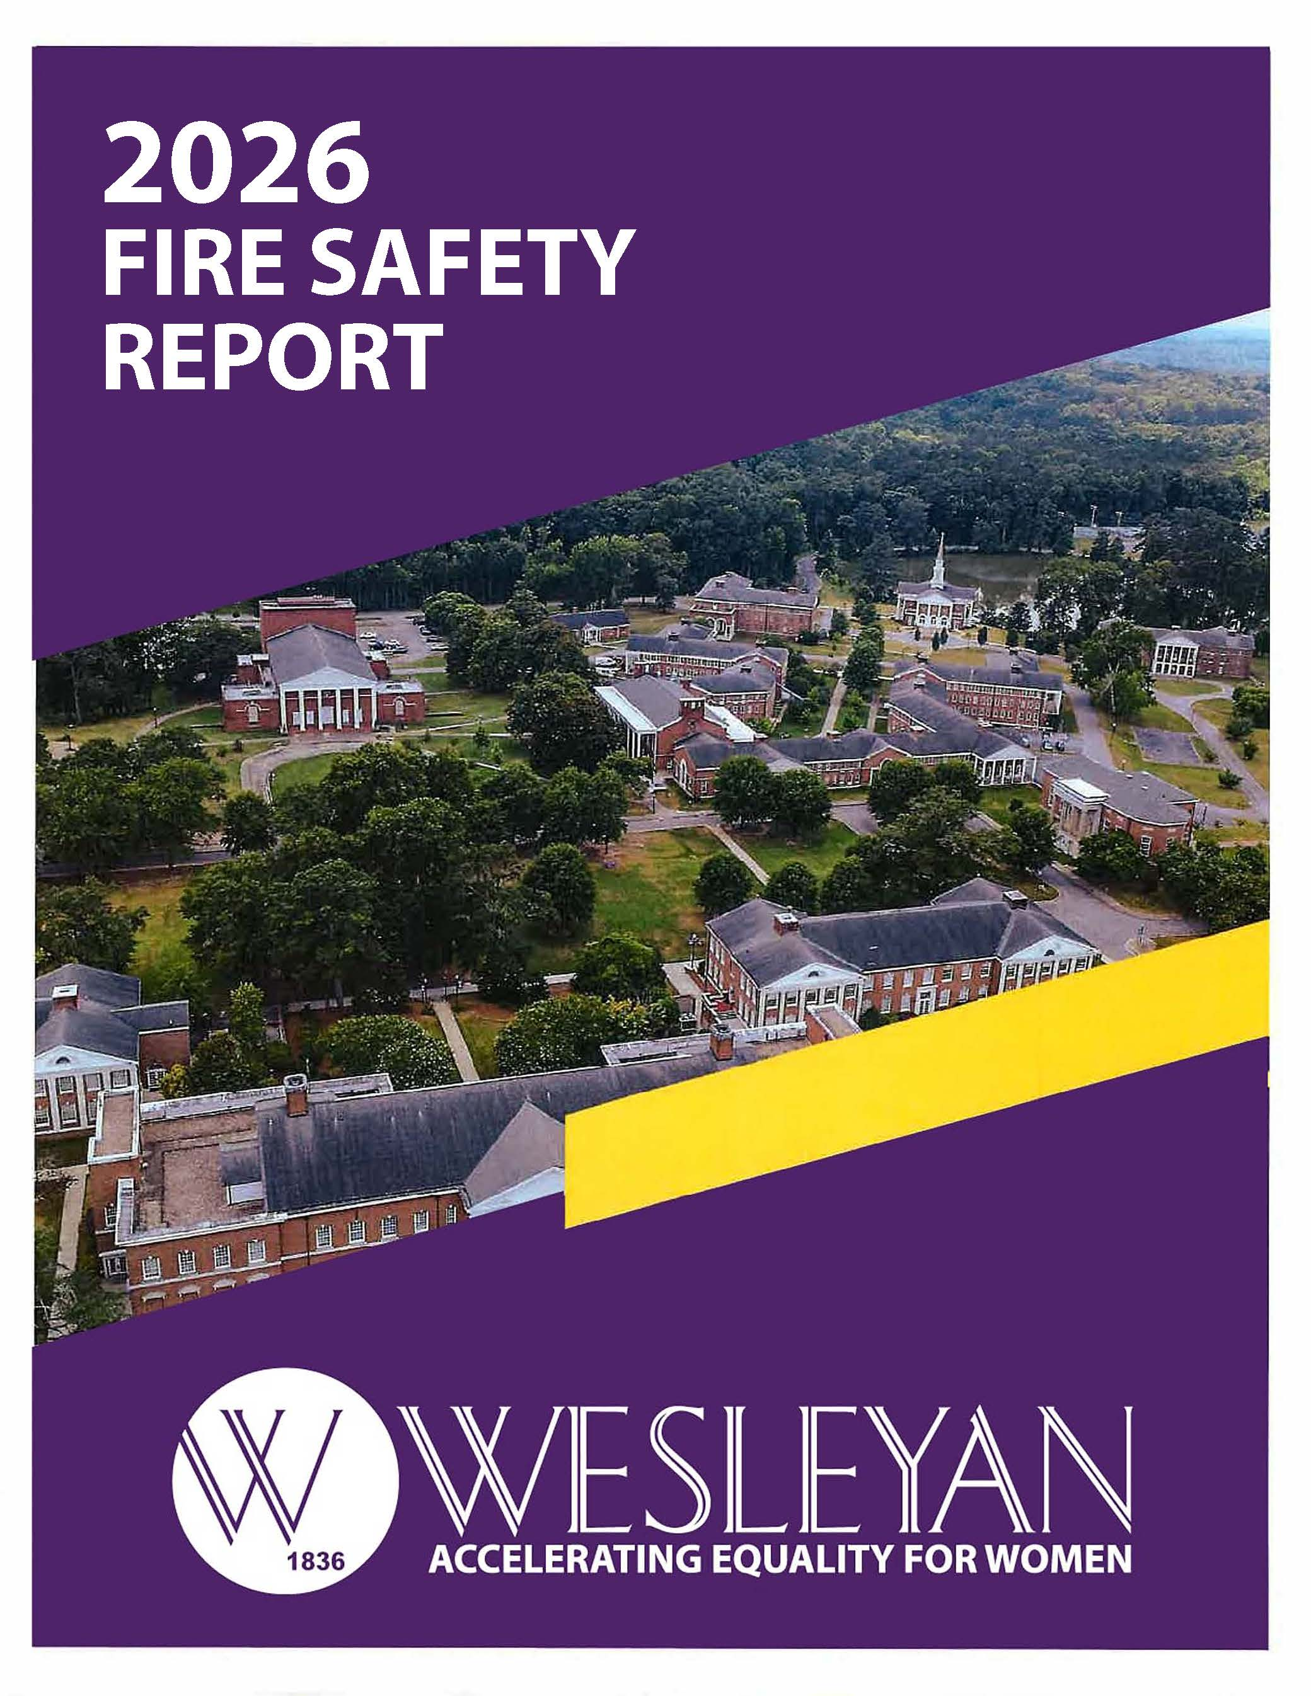

2026 Campus Fire Safety Report

2026 Wesleyan College Annual Fire Safety Report
Table of Contents

Clery Act Definitions: Fire Safety Definitions………………………………………………………….…………………..2
The Annual Student Housing Safety Report………………………………………………………………….....3
Fire Prevention System ………………………………..………………………………………………………………….3
COLLEGE POLICES AND RULES IN PREVENTION OF FIRE…………………………………………………………………4
FIRE SAFETY PROCEDURE………………………………………………………………………………………………………………5

FIRE SAFETY LOCATION…….………………………………………………..…………………………………………………5-6

Reporting a Fire……………………………………………………………………………………………………….……….7

Annual Student Housing Fire Safety Report

Fire Safety Definitions

Cause of fire: The factor or factors that give rise to a fire. The causal factor may be, but is not limited to, the result of an intentional or unintentional action, mechanical failure, or act of nature.
Fire: Any instance of open flame or other burning in a place not intended to contain the burning or in an uncontrolled manner.
Fire drill: A supervised practice of a mandatory evacuation of a building for a fire.
Fire-related injury: Any instance in which a person is injured as a result of a fire, including an injury sustained from a natural or accidental cause while involved in fire control, attempting rescue, or escaping from the dangers of a fire. The term person may include students, faculty, staff, visitors, firefighters or other individuals.
Fire-related death: Any instance in which a person: (1) is killed as a result of a fire, including death resulting from a natural or accidental cause while involved in fire control, attempting rescue, or escaping from the dangers of a fire; or (2) dies within one year of injuries sustained as a result of the fire.
Fire safety system: Any mechanism or system related to the detection of a fire, the warning resulting from a fire, or the control of a fire. This system includes sprinkler systems or other fire extinguishing systems, fire detection devices, standalone smoke alarms, devices that alert one to the presence of a fire, such as horns, bells, or strobe lights; smoke-control and reduction mechanisms; and fire doors and walls that reduce the spread of fire.
Value of Property Damage: The estimated value of the loss of the structure and contents, in terms of the cost of replacement in like kind and quantity. This estimate should include contents damaged by fire, and related damages caused by smoke, water, and overhaul: however, it does not include indirect loss, such as business interruption.
Fire log: (1) An institution that maintains on-campus student housing facilities must maintain a written, easily understood fire log that records, by the date that the fire was reported, any fire that occurred in an on-campus student housing facility.
This log must include the nature, date, time and general location of each fire. (2) An institution must make an entry or an addition to an entry to the log within two business days of the receipt of the information. (3) An institution must make the fire log for the most recent 60 day period open to the public inspection during normal business hours. The institution must make any portion of the log older than 60 days available within two business days of a request for public inspection. (4) An institution must make an annual report to the campus community on the fires recorded in the fire log.

Annual Student Housing Fire Safety Report
This report is in accordance with the Higher Education Opportunity Act (PL 110-315).
Wesleyan College’s fire safety rules and policies are intended to prevent fires, and fire-related injuries and deaths.

Residential Facilities
All Wesleyan College residential facilities are inspected annually by campus safety and physical plant. Additionally, Wesleyan College’s Department of Residence Life performs safety inspections at random times during the year to ensure compliance with the Residence Life fire safety policies. Because of the seriousness of the consequences that could result from failure to comply with fire codes and Wesleyan College Residence Life Policies, Wesleyan College takes disciplinary action on the first offense. Such action may include the imposition of a fine by Residence Life.
Copies of the Fire Safety Report can be found by contacting:
• Chief Jay Bartlett Department of Campus Public Safety
• In person: Olive Swann Porter (OSP) Leadership Suites
• By phone: 478- 757-2038
• By email: jbartlett@wesleyancollege.edu or campussafety@wesleyancollege.edu

Fire Prevention Systems

Fire Alarm Systems/Initiation-Pull Stations
Fire Alarm pull stations are generally located at exit doors, exit stairs, and corridors in Wesleyan College Housing facilities. Fire alarm activation automatically alerts the building occupants and automatically dials campus Safety. Campus Safety investigate the situation and call 911 if necessary.

Smoke Detection
Smoke detectors are located throughout each floor and in each room of Wesleyan College Residential facilities. If smoke is detected, the fire alarm system will notify the building
occupants through visual and audible alarms and automatically notify Campus Safety and the Fire Department.

Fire Extinguishers
Fire Extinguishers are located on each residence hall floor and in each kitchen. Residence Life Staff are trained each year on proper usage of a fire extinguisher.

Fire Evacuation Drills
The Wesleyan College Department of Residence Life in conjunction with Campus Safety and Physical Plant, conducted a minimum of 1 fire drill, per residential building, per semester. In addition, each fire alarm is tested during the summer.
Emergency evacuation drills are conducted within the first month of the beginning of classes each semester. The drills are conducted by activating every individual fire alarm system in each residence hall. After the fire alarm is activated, students and visitors must exit immediately and gather at the designated safe location. A sweep of all floors and a head count is conducted by Residence Life Staff. Only when the alarm is silenced and Campus Police gives the word “all clear, “may the building be re-entered. Students who do not vacate the building when the fire alarm is activated may be subject to judicial action.
College Policies and Rules in Prevention of Fire
Misusing or tampering with fire safety equipment. This includes, but is not limited to, fire extinguishers, hoses, horns, bells, conduit sections, alarm-pull stations, as well as pulling false alarms.
Obstructing hallways, sidewalks, or stairwells and impeding evacuation from building during an emergency.
Propping open fire doors.
Blocking or locking exit doors.
Storing bicycles in stairwells or any other location that might impede evacuation from a building during an emergency.
Possessing chemicals or substances that are potentially dangerous or highly flammable. This includes, but is not limited to, gasoline, propane, lighter fluid, etc.
Leaving food cooking unattended.
Failing to vacate the building when the fire alarm system is activated.

PORTABLE ELECTRICAL APPLIANCES
• Halogen lamps are prohibited in all residence halls.
• Hotplates are prohibited.
• Hover boards are prohibited.

SMOKING AND OPEN FLAMES
• Candles, incense, burners, and other open flame devices are strictly prohibited.
• Grills, hibachis, and other devices used for cooking over an open flame are prohibited.
• Using any items that are potentially dangerous/flammable, including fireworks, hazardous materials, etc. are prohibited.
• No tobacco products/vaping allowed on campus

Fire Safety Procedures – Residence Halls and Campus Facilities

Every time a fire alarm goes off, all building occupants must exit the building, unless they have been notified prior to the event that it is not necessary to evacuate (as in testing of the alarms, etc.).

Upon hearing the fire alarm:

Everyone will exit the building quickly and in an orderly fashion, assisting those who may need assistance. Whenever possible, employees will help maintain an approximate headcount of those from their offices, classrooms, or meeting place. Upon reaching the exterior gathering location, (see list below) employees will ensure that those under their jurisdiction or care do NOT re-enter the building until notified they may do so by emergency personnel. If there are injuries, Wesleyan College employees should notify Campus Safety as soon as possible after reaching the exterior gathering location. If an employee or student suspects that someone remains in the building, Campus Safety should be alerted to this fact immediately.
If you are unable to exit the building, go to the safest location of the building for fire (usually in a stairwell and identified as such by signage) and wait for emergency personnel to assist you in exiting the building.

While exiting the building:
Do not use elevators.
Attempt to maintain a calm and orderly exit.
Do not prop doors open.

Campus Fire Safety Locations: Emergency Assembly Area

Candler – Flagpole
Equestrian Center – Parking Lot E
Huckabee – Parking Lot B
Library –Flag Pole
Mathews Fitness Center – Parking Lot E
Munroe – Flagpole
Murphy – Parking Lot B
Olive Swann Porter – Flagpole
Physical Plant – Parking Lot B
Porter Auditorium – Flagpole
Porter Gym – Flagpole
Tate – Flagpole
Taylor – Flag Pole
Pierce Chapel – Grassy area by Hightower Hall
Residential Fire Safety Locations: Emergency Assembly Area
Banks Hall: Parking Lot B
Hightower Hall: Parking Lot B
Jones Hall: Parking Lot G
Persons: Flagpole
Wortham: Parking Lot G
Corn Hall/South Apartments: Parking Lot A

Annual Campus (non-residential) Safety Report
All Wesleyan College facilities are inspected annually by campus safety and physical plant. Additionally, Wesleyan College’s Campus Safety and Physical Plant Departments performs safety inspections at random times during the year to ensure compliance with all fire safety policies.

Copies of the Fire Safety Report can be found by contacting Chief Jay Bartlett

• In person: Olive Swann Porter (OSP) Leadership Suites 304
• By phone: 478 757-2038
• By email: jbartlett@wesleyancollege.edu or campussafety@wesleyancollege.edu.

Reporting a Fire

To report a fire, students, faculty, staff and visitors should call Campus Safety, at 478 960-7969 or 478-757-5145. If the fire is contained Campus Safety and members of the Physical Plant staff will assess the situation. If the fire is not contained, members of the community should pull the fire alarm and assist individuals in evacuation of the building.
Summary of Wesleyan College Annual Residential and Non – Residential Fire Incident STATISTICS

Residential Buildings - Fire Safety Report
BUILDING | YEAR | # FIRES | CAUSE | INJURIES | DEATHS | PROPERTY VALUE
PERSONS | 2023 | 0 | 0 | 0 | 0 | 0
 | 2024 | 0 | 0 | 0 | 0 | 0
 | 2025 | 0 | 0 | 0 | 0 | 0
WORTHAM | 2023 | 0 | 0 | 0 | 0 | 0
 | 2024 | 0 | 0 | 0 | 0 | 0
 | 2025 | 0 | 0 | 0 | 0 | 0
HIGHTOWER | 2023 | 0 | 0 | 0 | 0 | 0
 | 2024 | 0 | 0 | 0 | 0 | 0
 | 2025 | 0 | 0 | 0 | 0 | 0
JONES | 2023 | 0 | 0 | 0 | 0 | 0
 | 2024 | 0 | 0 | 0 | 0 | 0
 | 2025 | 0 | 0 | 0 | 0 | 0
NORTH | 2023 | 0 | 0 | 0 | 0 | 0
APARTMENTS | 2024 | 0 | 0 | 0 | 0 | 0
 | 2025 | 0 | 0 | 0 | 0 | 0
SOUTH | 2023 | 0 | 0 | 0 | 0 | 0
APARTMENTS | 2024 | 0 | 0 | 0 | 0 | 0
 | 2025 | 0 | 0 | 0 | 0 | 0

Non-Residential Buildings - Fire Safety Report
BUILDING | YEAR | # FIRES | CAUSE | INJURIES | DEATHS | PROPERTY VALUE
TATE | 2023 | 0 | 0 | 0 | 0 | 0
 | 2024 | 0 | 0 | 0 | 0 | 0
 | 2025 | 0 | 0 | 0 | 0 | 0
TAYLOR | 2023 | 0 | 0 | 0 | 0 | 0
 | 2024 | 0 | 0 | 0 | 0 | 0
 | 2025 | 0 | 0 | 0 | 0 | 0
MUNROE | 2023 | 0 | 0 | 0 | 0 | 0
 | 2024 | 0 | 0 | 0 | 0 | 0
 | 2025 | 0 | 0 | 0 | 0 | 0
BANKS | 2023 | 0 | 0 | 0 | 0 | 0
 | 2024 | 0 | 0 | 0 | 0 | 0
 | 2025 | 0 | 0 | 0 | 0 | 0
PORTER GYM | 2023 | 0 | 0 | 0 | 0 | 0
 | 2024 | 0 | 0 | 0 | 0 | 0
 | 2025 | 0 | 0 | 0 | 0 | 0
PORTER | 2023 | 0 | 0 | 0 | 0 | 0
AUDITORIUM | 2024 | 0 | 0 | 0 | 0 | 0
 | 2025 | 0 | 0 | 0 | 0 | 0
POTER (OSP) | 2023 | 0 | 0 | 0 | 0 | 0
OLIVE SWANN | 2024 | 0 | 0 | 0 | 0 | 0
 | 2025 | 0 | 0 | 0 | 0 | 0
CANDLER | 2023 | 0 | 0 | 0 | 0 | 0
 | 2024 | 0 | 0 | 0 | 0 | 0
 | 2025 | 0 | 0 | 0 | 0 | 0
MURPHY | 2023 | 0 | 0 | 0 | 0 | 0
 | 2024 | 0 | 0 | 0 | 0 | 0
 | 2025 | 0 | 0 | 0 | 0 | 0
ATHLETIC | 2023 | 0 | 0 | 0 | 0 | 0
CENTER (MAC) | 2024 | 0 | 0 | 0 | 0 | 0
MATHEWS | 2025 | 0 | 0 | 0 | 0 | 0
EQUISTRIAN | 2023 | 0 | 0 | 0 | 0 | 0
CENTER | 2024 | 0 | 0 | 0 | 0 | 0
 | 2025 | 0 | 0 | 0 | 0 | 0
PHYSICAL | 2023 | 0 | 0 | 0 | 0 | 0
PLANT | 2024 | 0 | 0 | 0 | 0 | 0
 | 2025 | 0 | 0 | 0 | 0 | 0

